VREME ZA REALIZACIJU ZADATKA 60 MINUTA. MAKSIMALNO 20 BODOVA.
Zadatak 1
U priloženu kartu (Fig. 1) ucrtaj putanju kojom ste se kretali od T₁ do T₂.
(maksimalno 4 bodova)
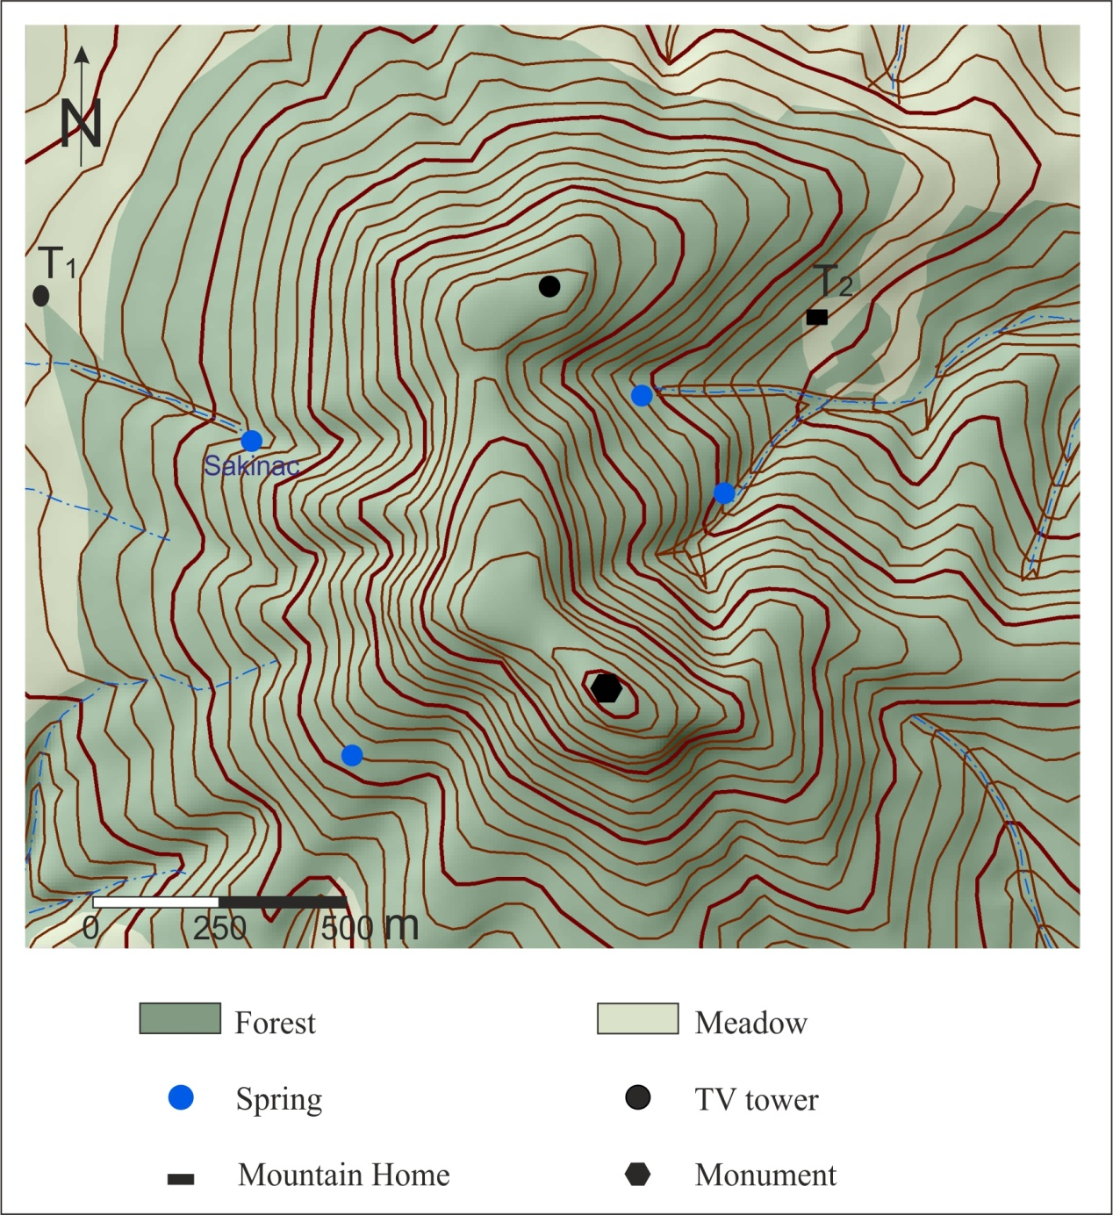
Fig. 1 - Map of Avala
Zadatak 2
Koji oblici u su najzastupljeniji na Avali i kako su oni nastali?
_______________________________________________________________________________________
_______________________________________________________________________________________
_______________________________________________________________________________________
______________________________________________________________________________________ .
(maksimalno 5 bodova)
Zadatak 3
Kojim tehničkim merama je sprečena pojava prirodnih nepogoda na Avali? Kako deluju te tehničke mere?
_______________________________________________________________________________________
_______________________________________________________________________________________
_______________________________________________________________________________________
_______________________________________________________________________________________
_______________________________________________________________________________________
_______________________________________________________________________________________
_______________________________________________________________________________________
______________________________________________________________________________________ .
(maksimalno 6 bodova)
Zadatak 4
Koje su turističke vrednosti Avale? Navedi minimalno 5.
1. ____________________________________

2. ____________________________________

3. ____________________________________

4. ____________________________________

5. ____________________________________

6. ____________________________________

7. ____________________________________
(maksimalno 5 bodova)

