
BIGEO 3 2017
SOUTHEASTERN EUROPE GEOGRAPHY OLYMPIAD
Fieldwork
instructions

Follow your group-guide, her/his explanations and time-table. When the group is moving, do not move away from it. The route is planned so that you will see all informations you need in the afternoon.
Use this instructions and materials (maps and sources) you are supplied with.
Write down your notes, sketch, and observations; draw in maps and sources. You will need your collected data (and use them) in the afternoon during fieldwork test.
Fieldwork test is based on three types of tasks:
- First type is based on general impression you will get it during morning observations.
- Second type is based on facts and process that are pointed out in these instructions.
- Third type is based on additional material you will get in the afternoon. Material is connected to the morning observations.
The focus of observations will be on former Ruše Nitrogen Factory, town Ruše, uninhabited space between them, slopes of Pohorje and Kobansko, Drava River, the valley of Drava.
Instructions:
Mark on each map (you are supplied with) your location. But not on maps Plan Ruše North - factory and Plan of Ruše South – town center for the scale is too big.

Draw trace of your walking with the line on maps Plan Ruše North - factory and Plan of Ruše South – town center. Warning: maps are not covering your entire route.

Find Fala hydropower plant on maps and mark it on the map Detailed map. You can ask colleagues or guide for help. The foundation of the dam is at an altitude of 280 meters. The barrier is 16 m high. In case of collapse of the dam, would it be more in risk the area of Ruše or the area of Selnica ob Dravi? On the bottom map, you can find four altitudes. But even more precise altitudes are cleared from brown contour lines (izohipses).
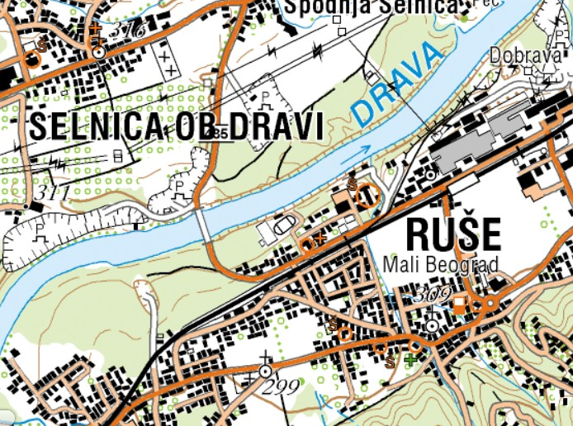

The main observation points are town center and factory.

In factory:
- Estimate how big is the area of factory
- What is it used now?
- Are buildings renovated?
- How it is linked to external traffic?
- What percentage of buildings and non-building areas are used today?
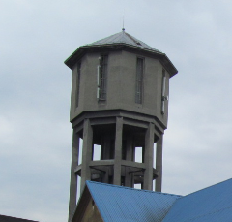
- Think about how to use the plant (factory area) in the future.
- Assess the current natural and social impact of the plant on the environment and its surroundings.
- Find the plumbing tower (picture right), evaluate its height and mark it in the map Plan Ruše North – factory.
- Assess how far and how deep from tower is the river Drava.
- Be aware that there were more workers once in the factory than there was population of Ruše. Moreover, most of infrastructure of Ruše, including school, hostel and swimming pool was financed by factory.

In town center:
- Mark (indicate with signs) shops, inns and restaurants.in the map Plan of Ruše South – town center.
- Mark in the map Plan of Ruše South – town center post office, bridges over the stream (small river), church, municipal house, parks.
- Encircle (hatch) in the map Plan of Ruše South – town center areas of residential houses, apartment blocks, old houses.
- Take a look at road traffic density and find out if personal or freight traffic predominates.
- Assess whether personal cars are lower, middle or high class.
- Assess whether the traffic for pedestrians and cyclists is safe.
- Assess whether the pedestrians are adults, children or elderly; whether they are locals or tourists.
- Identify and indicate on the map if there are abandoned and neglected houses/buildings among buildings.
- Are new buildings being built in the city? Are old buildings being renovated?

On the way between the factory and the city center, observe and mark what the unpaved surfaces are to the left and to the right of the road. Are there fields, meadows, orchards, parks, recreational or abandoned areas?

On the way between the factory and the city center, think about the natural relief that is shown in River teraces model. Evaluate the difference in altitude between the factory and the center.

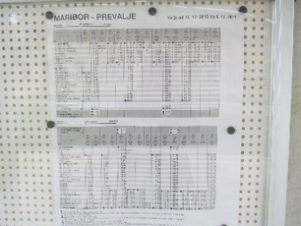
Visit the railway station and find out if the timetable on it is the same as in the material you received. Check if the stop/station is accessible for people with disabilities and prams (baby carriage or stroller). Find out if there is a parking lot at the stop where the passengers would leave cars.

Observe the slopes of Pohorje and Kobansko. Find out which vegetation is on them. At what level is the forest boundary in this region?

Do you think that the Ruše town grew in a plan or a styche (random)? Is the layout of the site correct and geometric, or accidental and irregular?

Do you think that this region has problems with water supply? Why do you think so?

Do you think there are enough shops and other supply activities in the city? Which activity is missing, which is redundant?

Would you, as a tourist, personally find something interesting in Ruše and its surroundings? What, for example?

How would you describe the observed landscape in a few sentences?

Do you think there are enough green spaces between the houses?

How do you imagine the image (landscape) of this place in winter?

Enjoy your research and do not forget to bring the material and your notes to the afternoon test.

