REGIONAL CENTER FOR TALENTED YOUTH BEOGRAD II

Written Test

NAME______________________________________________________

SURNAME______________________________________________________

SCHOOL______________________________________________________

Written Test

Instructions:

- Please write your name

- The time alloacted for this examination is three hours.

- Please write your answers legibly. Illegible answers will be counted as incorrect.

- Please keep your answers short and focus on the key points.

- Please write your answers only on the white test booklet provided.

- For some questions, you will be asked to provide your answers on the figures. Please do so carefully.

Formulae for references:

m-M = -5+5⋅log(d); 1 parsec (pc) = 3.26 ly;

where m is apparent magnitude, M is absolute magnitude and d is distance measured in pc.

Stefan-Boltzmann Law E =σT⁴,

where σ is the Stefan-Boltzmann constant and T is temperature in K.

- The figure below is the surface weather map for the region of western North Pacific at 00 UTC (Coordinated Universal Time, same as the Greenwich Mean Time), 25 October 2004. Please answer the following questions:

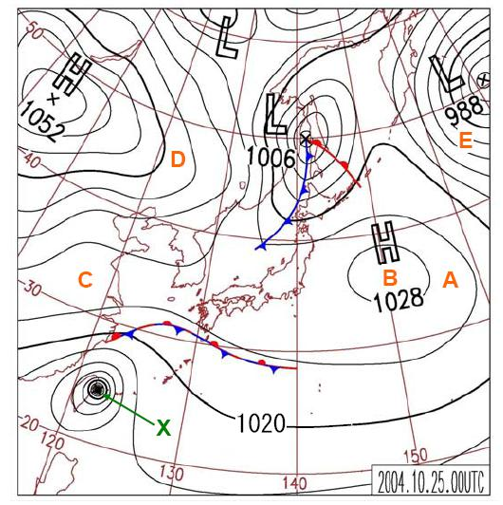

(A) The contour lines on the map are produced by analyzing which of the following meteorological variables?

(A) Altitude
(B) Pressure

(C) Temperature
(D) Humidity

(E) Wind

(B) THE weather system labeled as “X” (in green color) in the above figure should . be which of the following?

- An extra-tropical cyclone
- A continental anticyclone
- A tropical cyclone
- A migratory
- A front

(D) The wind direction at point “A” should be close to which of the following?

(A) Easterly wind
(B) Southerly wind

(C) Westerly wind
(D) Northerly wind

(E) The wind is calm at point

(E) Among the five locations labeled from “A” to “E” in the map, which should . have the strongest wind of all?

A B C D E

- Which of the following gases in the atmosphere has the largest variations in spatial and daily-time scales and has strong impact on local weather?

(A) CO₂ | (B) CO | (C) H₂O | (D) O₃ | (E) He

- What is the most likely reason why typhoons are rarely observed over the ocean near the Equator?

(A) Sea surface temperature is too high
(B) Pressure gradient is too weak

(C) Coriolis force is too small
(D) Convection is not strong enough

(E) Wind is too

- Regarding the mean value and the range of annual temperature cycle, please answer all the true/false questions below. For your information, a world map is provided below and the locations of the cities mentioned in the questions are also marked.
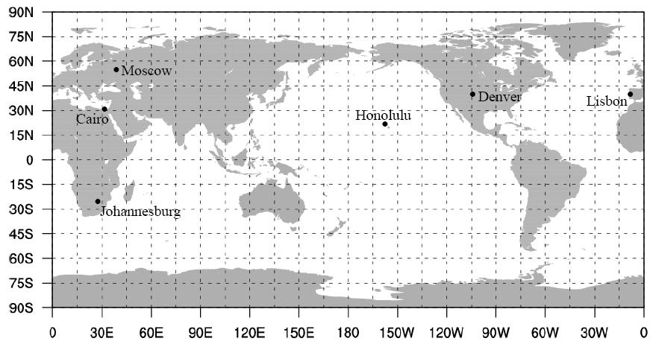

- The annual temperature range in the northern hemisphere, as a whole, is larger than that in the southern hemisphere. . 1. True or 2. False

- The annual mean temperature at Moscow (56°N, 38°E) is lower than that at Cairo (30°N, 31°E).
1. True or 2. False

- The annual temperature range at Denver (40°N, 105°W) is smaller than that at Lisbon (39°N, 9°W).
1. True or 2. False

- The average temperature in July at Honolulu (21°N, 158°W) is slightly lower than that at Johannesburg (26°S, 28°E).
1. True or 2. False

- Which time of a day in the lower troposphere has the highest possibility for clear air turbulence to occur?

(A) Morning | (B) Noon | (C) Afternoon | (D) Evening | (E) Midnight
- The figure below shows the globally-averaged vertical profile of atmospheric pressure from the sea level to 50 km in altitude. Please answer the questions below:
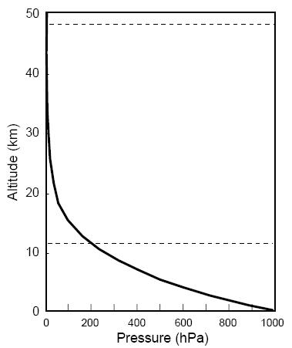

A. The term “pressure” on the horizontal axis is equivalent to which of the following?
(A) Force divided by area
(B) Mass divided by area
(C) Density multiplied by temperature
D) Mass multiplied by distance

(E) Weight divided by volume

- Which of the following pressure layer has the greatest altitude difference (i.e., thickness)?

- 1-10 hPa
- 101-110 hPa
- 501-510 hPa
- 510-1010 hPa
- 1001-1010 hPa

- In the static atmosphere, the change in pressure with height is governed by the hydrostatic equation, expressed as p = ρg z, where g is the gravitational acceleration in m/s² (g = 9.81 m/s²), ρ is air density in kg/m³, and p and z are pressure difference in Pa and thickness in meter at two fixed altitudes. If the averaged air density from the 1000 hPa to 500 hPa (where 1 hPa = 100 Pa) is about 0.910 kg/m³, please apply this equation to find the height of the 500-hPa pressure level.

Please show your calculation

Answer:

- If the temperature for the air released from a bicycle tire hole is T₁ and the temperature of air around this bicycle is T₂, which temperature is lower?

Answer:______________________

- If lots of dust is blown into the atmosphere during a volcano eruption, how will it change the atmospheric temperature in the local area surrounding the volcano due to the dust effect?

(A) Increase (B) Decrease (C) Remain the same (D) Not certain

- The figure below depicts the time variation of annual global mean surface temperatures (black dots) from 1850 to 2005. The long term variation of global average surface temperature includes decadal variation (smooth blue curve) and linear trends (straight lines). The right hand axis shows estimated actual temperature. The left hand axis shows temperature anomalies relative to 1961-1990 average. Please answer the following questions.

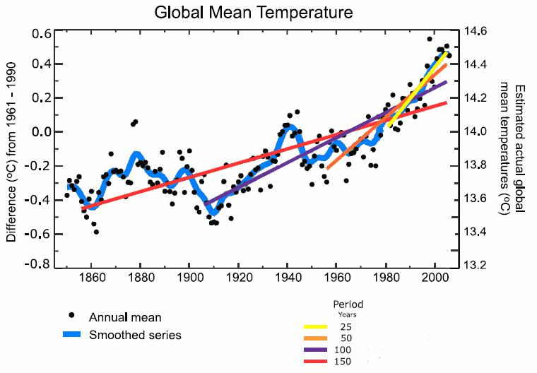

(Source: IPCC AR4, 2007)

- Linear warming trends (°C/year) in global average surface temperature for the last 25, 50, 100 and 150 years are shown as yellow, orange, purple and red lines, respectively. Which period has the greatest linear warming trend?
- the last 25 years
- the last 50 years
- the last 100 years
- the last 150 years

- Please calculate the linear warming trend (°C/year) in global average surface temperature for the last 50 years (1956-2005), the last 100 years (1906-2005) and their ratio (the last 50 years /the last 100 years).

Answer:

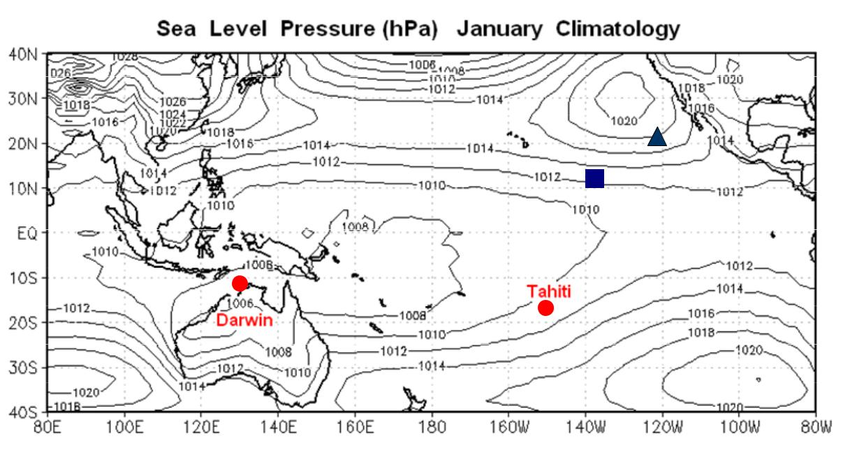
- The figure below shows the distribution of sea level pressure in January averaged for 40 years (climatology) over the tropical Pacific. Surface wind, ocean currents and sea surface temperature (SST) are closely related in the tropical Pacific Ocean. Please answer the following questions. (Refer to the following figure for questions 10(A), 10(B), and 10(C)

- Please plot the direction of trade wind at point labeled as “” and equatorial current at point labeled as “” in the above figure.

( Please use the symbol 〝 → 〞for trade winds, and the symbol 〝〞for equatorial currents )

- Trade winds are related to the surface pressure gradient. Figure below displays the time series of sea-level pressure at Darwin (12°S, 131°E) and Tahiti (17°S, 149°W). Please write down the surface pressure gradient and the speed of the trade wind between Tahiti and Darwin in January 1998, 1999 and C (climatology) in descending order (example: 1998 > 1999 > C).

 | 1017
(hPa) | 1016
(hPa) | 1014
 | 1015
Pressure | 1013
Pressure | 1012
 | 1011
Level | 1010
Level | 1009
 | 1008
Sea | 1007
Sea | 1006
 | 1005
 | 1004

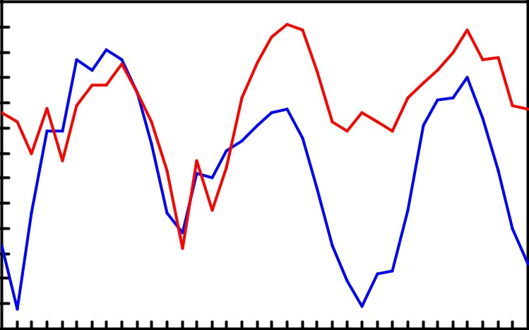

Jan May Sep | Jan May Sep |  |  | Jan May | Sep
1997 | 1998 |  |  | 1999
Answer: Surface pressure gradient : |  |  |  | > | >
Trade winds | : |  |  | > | >

Darwin

Tahiti

- In January of which year, 1998 or 1999, is the SST over the eastern equatorial Pacific Ocean warmer?

Answer:

- The following figure shows the long-term average temperature profiles from the surface down to the depth of 2,000 m compiled at two stations – Station A in the western equatorial Pacific Ocean at 140°E and Station B in the eastern equatorial Pacific Ocean at 120°W. Which of the following statements is true?

  - Profiles compiled at Station A and B can be presented by X and Y respectively.

  - Profiles compiled at Station A and B can be presented by Y and X respectively

0

1000 Depth (m)

2000

Temperature (oC)
0 10 20 30
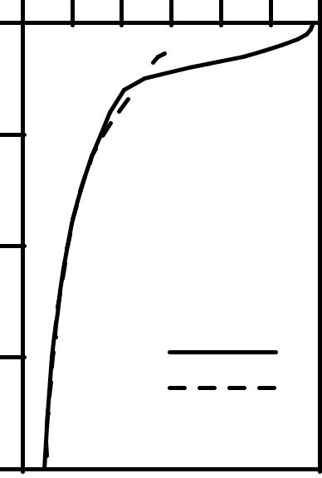

- 

X

X

Y

- A strong ocean current flows northwards in the Northern Hemisphere as shown in the figure below. Which one of the arrows is correct?
(A) A
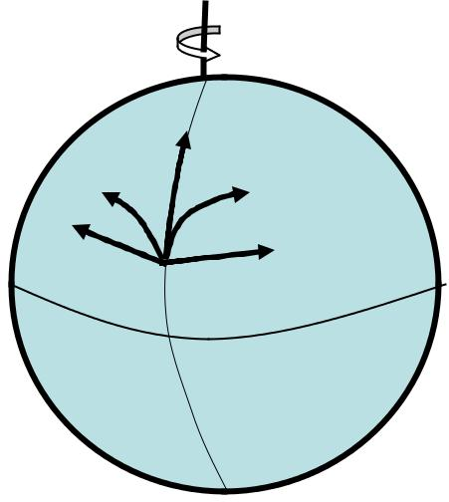

(B) B

(C) C
(D) D |  |  | (C)
(D) D |  | (B)
(E) E |  | (B) | (D)
(E) E |  | (A) | (D)
 |  | (A) | (E)
 |  |  | Equator

- Mesoscale eddies in the ocean can be detected by satellite altimeters. The color figure below shows contours of the sea surface dynamic topography at an area in the western North Pacific Ocean. The contour interval is 5 cm. Generally speaking, the surface flow field of these eddies can be depicted based on geostrophic equilibrium. Please draw arrows (→) to indicate the directions of surface currents at the six white dots in the figure below.

Latitude (N)

25 |  | Sea Surface Dynamic Topography (cm)
 |  |  |  |  |  |  |  |  |  | 295
24 |  |  |  |  |  |  |  |  |  | 290
 |  |  |  |  |  |  |  |  |  | 285
23 |  |  |  |  |  |  |  |  |  | 280
23 |  |  |  |  |  |  |  |  |  | 275
 |  |  |  |  |  |  |  |  |  | 270
22 |  |  |  |  |  |  |  |  |  | 265
 |  |  |  |  |  |  |  |  |  | 260
21 |  |  |  |  |  |  |  |  |  | 255
21 |  |  |  |  |  |  |  |  |  | 250
 |  |  |  |  |  |  |  |  |  | 245
20 |  |  |  |  |  |  |  |  |  | 240
 |  |  |  |  |  |  |  |  |  | 235
19 |  |  |  |  |  |  |  |  |  | 230
19 |  |  |  |  |  |  |  |  |  | 225
 |  |  |  |  |  |  |  |  |  | 220
18 | 131 | 132 | 133 | 134 | 135 | 136 | 137 | 138 | 139 | 215
130 |  |  |  |  |  |  |  |  |  | 140
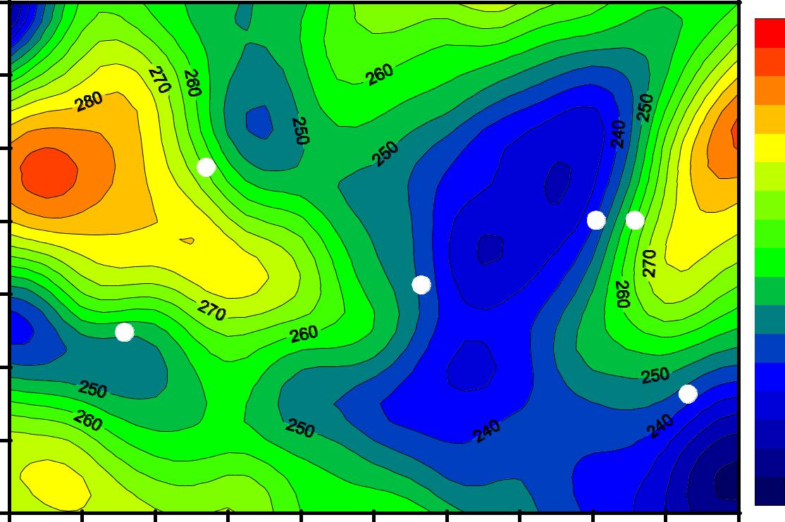

Longitude (E)

- It is known that the salinity of the Mediterranean seawater is always higher than that of the Atlantic Ocean.

- The relation among evaporation (E), precipitation (P) and river runoff (R) for the

Mediterranean can be expressed by

(A) E > P + R
(B) E < P + R
(C) P > E + R
(D) R > E + P

- Which of the following flow patterns between the Mediterranean Sea and the Atlantic Ocean is correct?

(A)

Depth (m)

(B)

Depth (m)

(C)

Depth (m)

500

1000

500

1000

500

1000

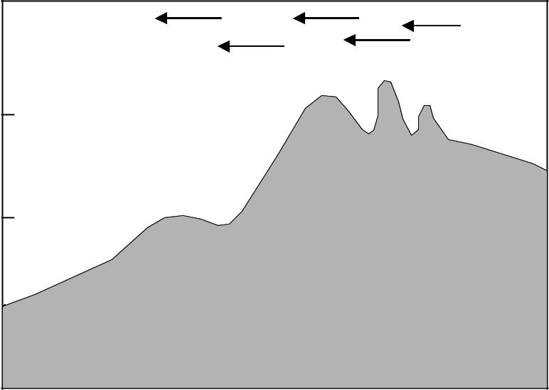

Mediterranean
Atlantic Ocean
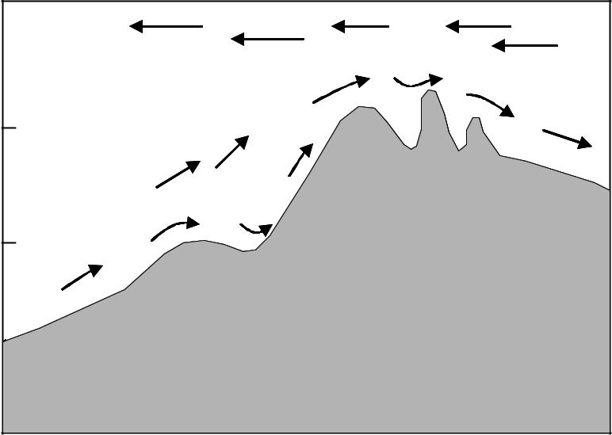

Mediterranean
Atlantic Ocean
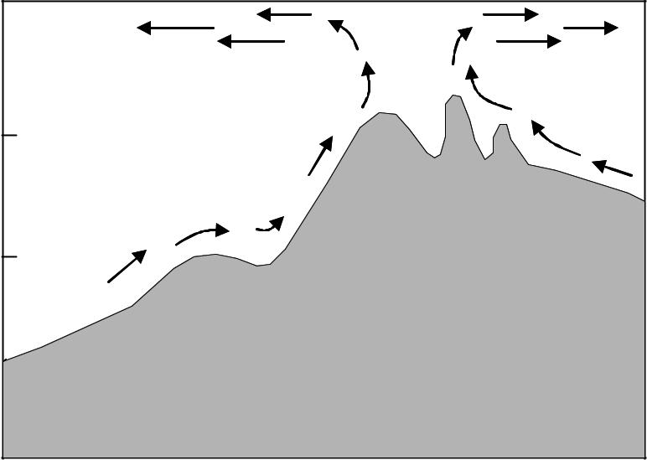

Mediterranean
Atlantic Ocean

(D)
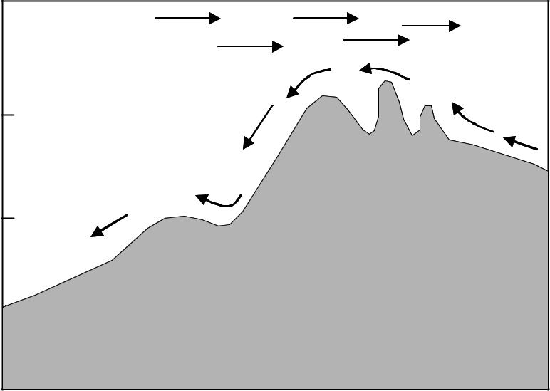

Depth (m)

Mediterranean
Atlantic Ocean

500

1000

(E)
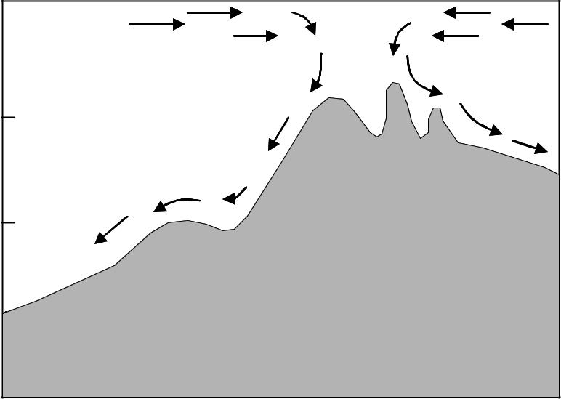

Depth (m)

Mediterranean
Atlantic Ocean

500

1000

- Nowadays, astronomers believe that the solar system formed from a cloud of interstellar gas and dust about 4.6 billion years ago. The pictures below show the representative stages in the phases of the formation. Arrange the order of the pictures to demonstrate the formation process.
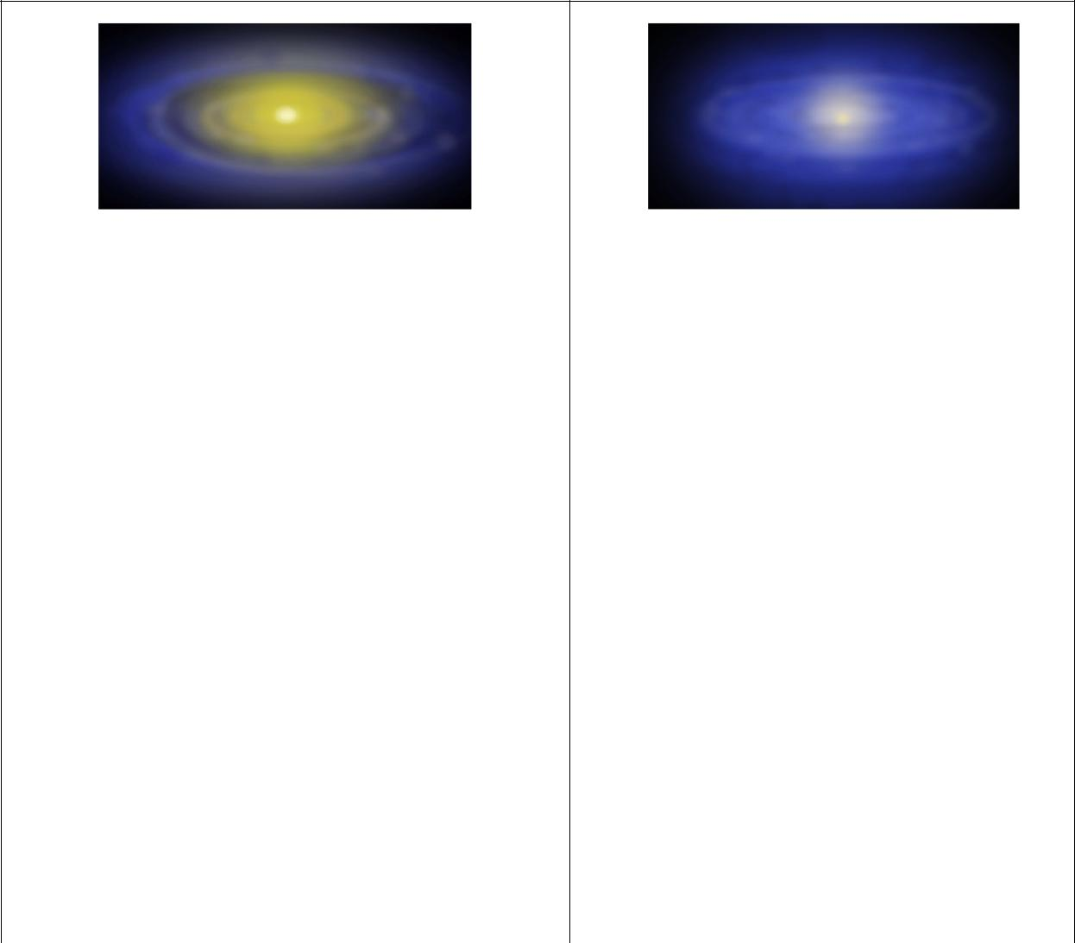

Figure (a). The Sun became hotter and drifted | Figure (d). The protosun has begun to
the gas from the inner region, leaving | shine, with a flattened disk of gas
heavier debris revolving in orbits. | and dust surrounding it.


Figure (b). The planets have been accreting in | Figure (e). The protosun formed at the
their orbits. | center and the cloud rotated faster.
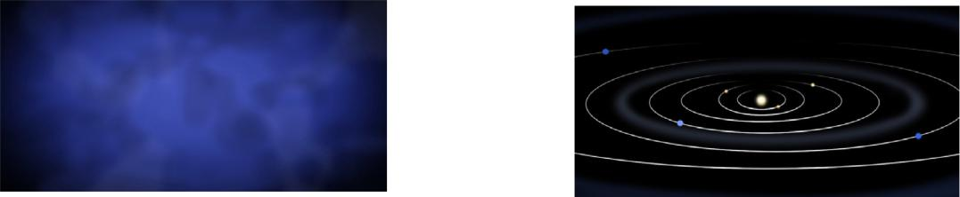

Figure (c). A cold, slowly rotating cloud | Figure (f). The planets were formed and
began to contract under its own gravity. | Figure (f). The planets were formed and
began to contract under its own gravity. | orbit the Sun.

Answer: ( c ) → ( ) → ( ) → ( ) → ( ) → ( f )

- The following diagram gives the predicted positions of the four moons relative to Jupiter. The number 1, 2, 3 and 4 indicate the tracks of Io, Europa, Ganymede and Callisto respectively. The width defined by the two lines marks the visual disk of Jupiter. The E and W give the east and the west as view from the Earth. The ordinate marks the date. Now, we have a photo of Jupiter and its moons taken in 2008 October but the date is unknown. Use the predicted diagram to allocate the four moons and to estimate the date for photography.
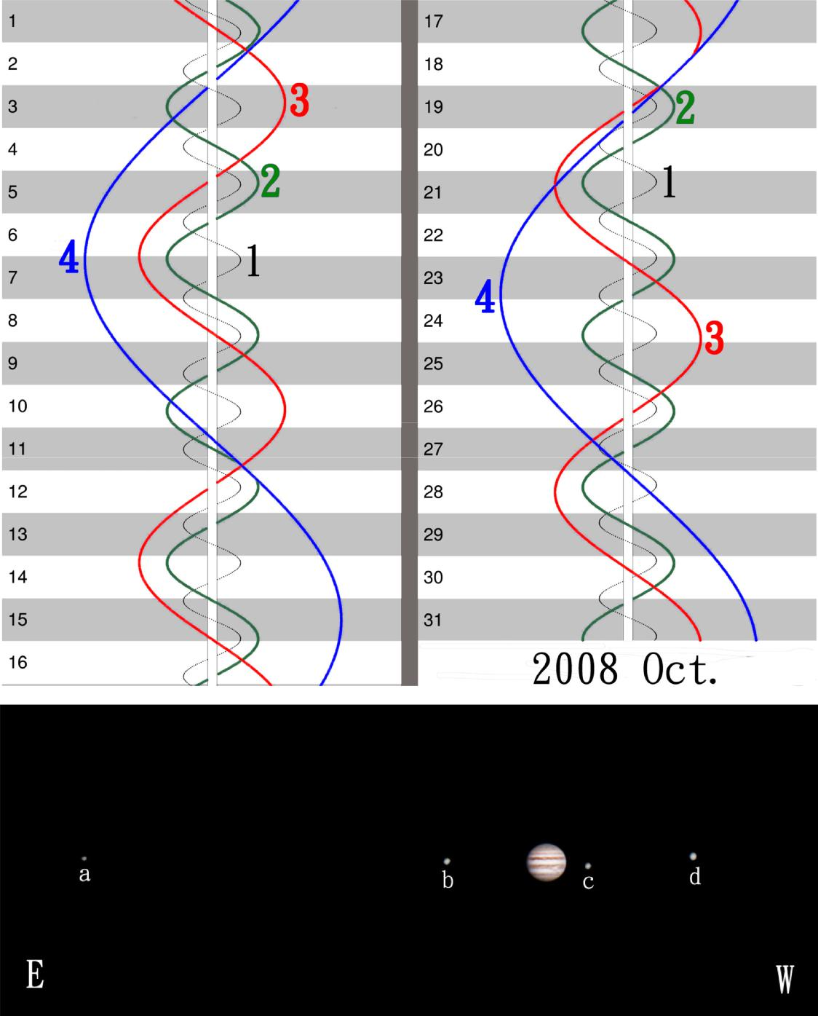

Answer:  The photo was taken at the night of 2008 Oct. ( |  |  |  |  | )
The satellites are a: ( |  | ) ; b: ( | ) ; c: ( |  |  | ) ; d: ( | )

17. We have four mineral specimens. All four are Mohs’ scale standard minerals, both topaz and apatite are absent. Hardness tests show that: (1) only one out of the four is harder than topaz, and (2) only one is softer than apatite. Furthermore, the above two are both isometric crystals. Among the four specimens, the one softer than apatite is

(A) calcite (B) gypsum (C) fluorite (D) quartz (E) talc

18.. What is the major greenhouse gas trapped in the frozen soils of the tundra and continental shelf sediments?

(A) methane | (B) carbon dioxide (C) water vapor (D) ethane | (E) nitrogen

- Based on the geochemical equilibrium of the Earth system, the increase in burial rate of organic matter in the sediments could most likely result in

  - a reduction in the Earth's atmospheric N₂ and an increase in CO₂ levels
  - an increase in the Earth's atmospheric N₂ and reduction in CO₂ levels

  - a reduction in the Earth's atmospheric CO₂ and an increase in O₂ levels
  - an increase in the Earth's atmospheric CO₂ and a decrease in O₂ levels

  - a reduction in both CO₂ and O₂ levels

- When the strength of rock material is greater, it tends to fracture or break more easily; conversely, when the rock is softer, it tends to bend and change its shape more easily. Based on that, assume the outer layers in a, b and c have the same strength and are under the same stress conditions for every sample. Please rank the strength for deformation of the following geological structures (a, b and c) from low to high. (1 pt)

a b c
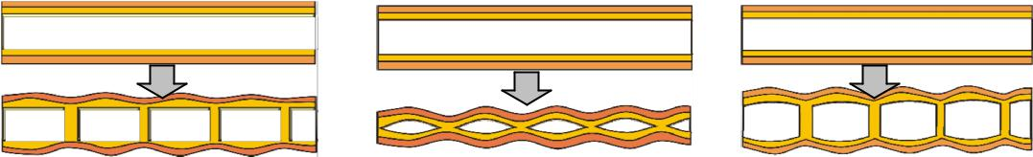

- a-b-c
(B) b-a-c
(C) c-b-a
(D) a-c-b
(E) b-c-a

21. Circle the specimen(s) that is/are from vertebrate organisms?

(A) (B)
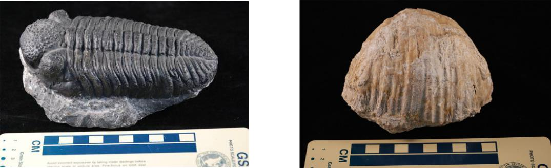

(C) (D)
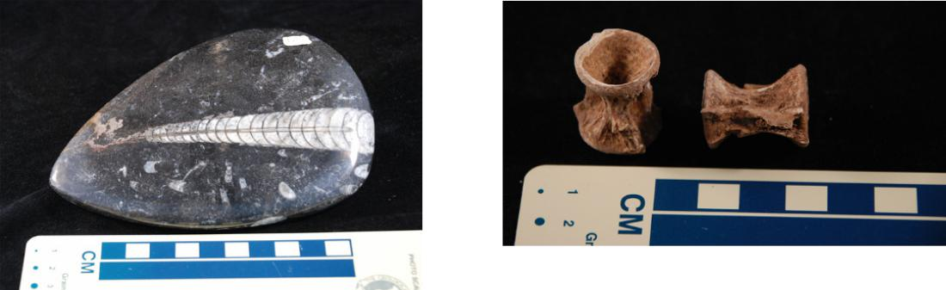

(E) (F)
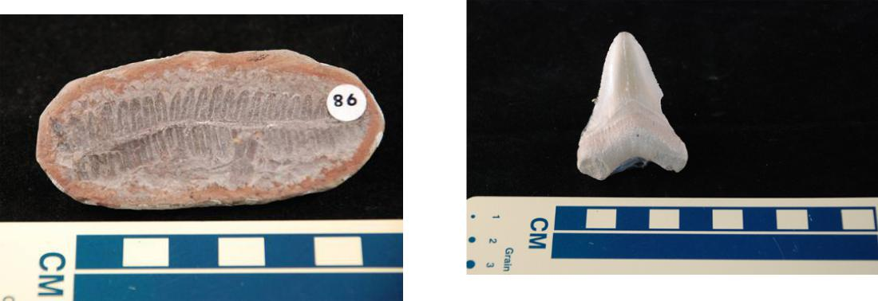

22.. What type of material or celestial body gives us the most information in order to estimate the bulk chemical composition of the Earth? Choose the most suitable one from the list below.

(A) comets (B) Mars (C) Moon (D) meteorites (E) oceanic crust

- Which one of the following terms best describes the structure illustrated? (1 pt)

  - upright fold

  - antiformal anticline

  - synformal syncline

  - fault propagation fold

  - normal fault
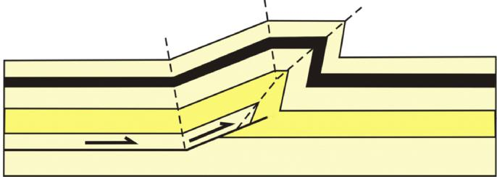

24. The figure below shows a type of landform which consists of sand. What is the most likely prevailing local wind direction?
(A) from low right to upper left
(B) from upper right to lower left

(C) from upper left to lower right
(D) from lower left to upper right

(E) no prevailing wind direction can be identified.
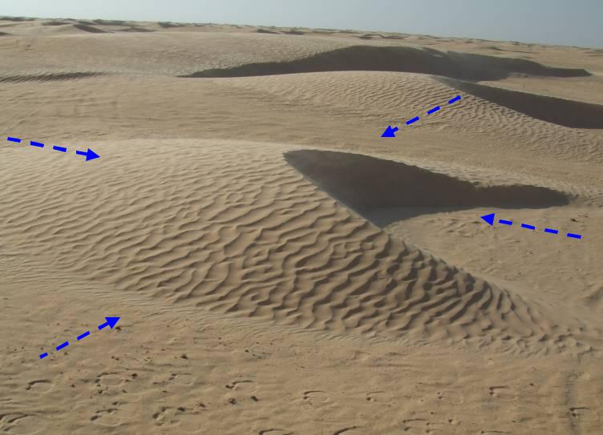

(C) (B)

(A)

(D)

25.. The photographs below were taken from a low-lying basaltic island in the subtropical zone. On this island, horizons A and B in the soil profile are characterized by reddish-brown color. Which is the most important factor for such a soil to develop?

(A) plant type (B) climate (C) relief (D) sea breeze

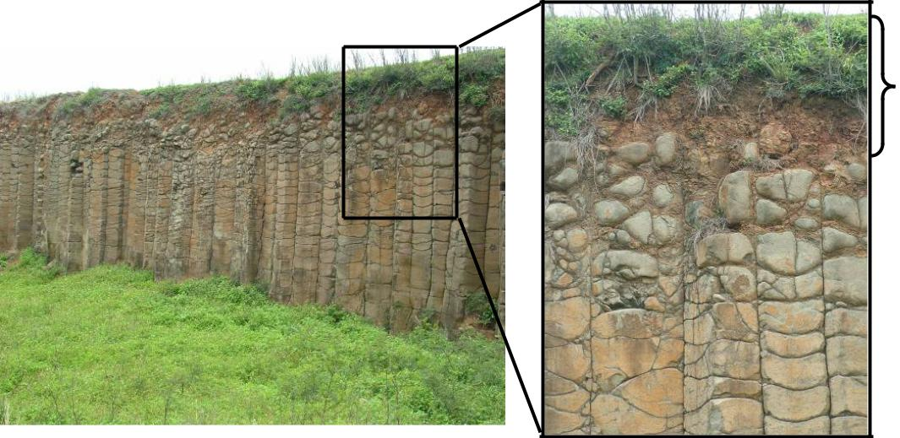

Horizon A & Horizon B

26. The figure below shows the typical hill slopes developed on a massive mudstone bedrock. Two major processes could have contributed to erosion in this area and one of them is sheet wash. Please identify the other major process.

(A) debris flow
(B) rockfall
(C) rill erosion

(D) channel cutoff
(E) river bank erosion
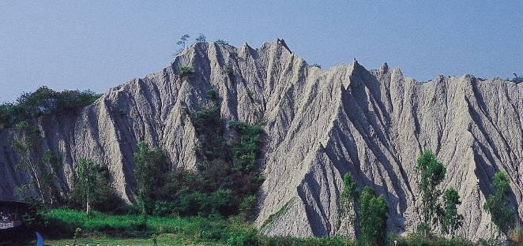

27. Which type of rock is most commonly found at a mid-ocean ridge?

(A) granite (B) rhyolite (C) dacite (D) basalt (E) sandstone

- The figure below illustrates the empirical relationship between the earthquake magnitude and the rupture area (RA) along the fault plane. Assume that the rupture of the May 12, 2008 Wenchuan, China earthquake (M=8) occurred within a rectangular plane with a maximum depth of 15 km and a dip angle of 30º. Estimate the rupture length on the surface if the fault plane penetrated the ground surface. (Show your work in the space next to the figure;

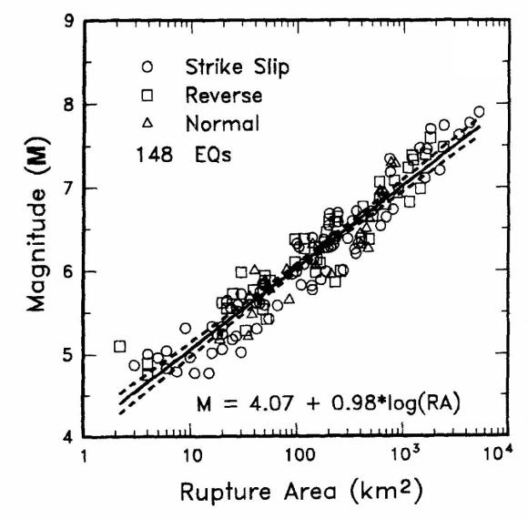
Answer:

- Assume that you are travelling along the northern margin of the Sahara Desert where vegetation cover is poor and the bedrock is exposed and readily observed (see photograph below). This rugged topography is characterized by many small ridges (indicated with arrows). Please draw a cross section to show the relationship between the lithology and topography. Use ‘M’ for mudstone and ‘S’ for sandstone to label the rocks.
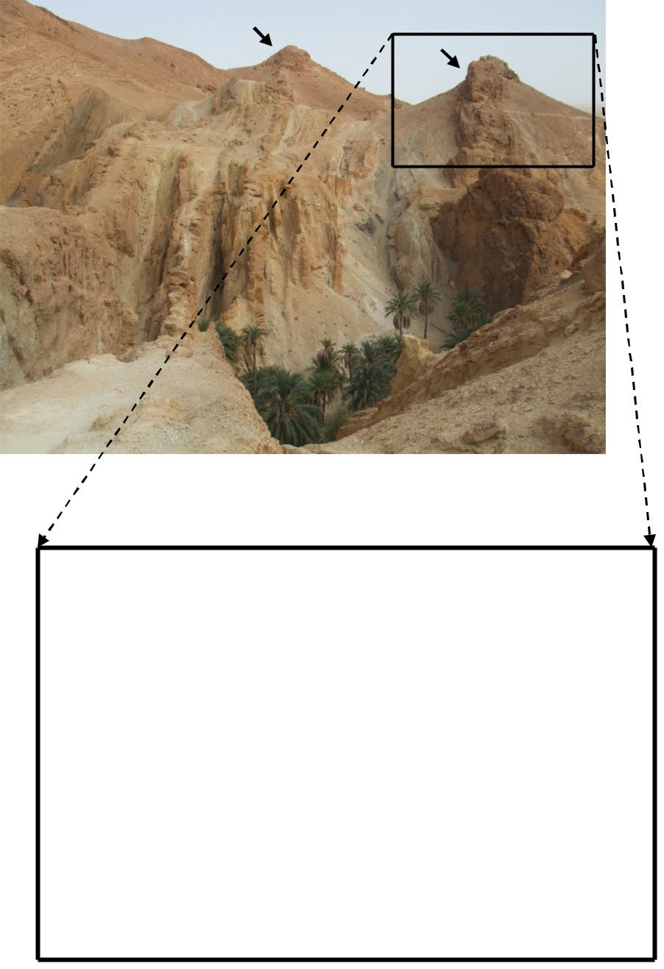

palm trees

Answer:

- Which one of the following is a primary structure?

- fold axial plane (B) fault

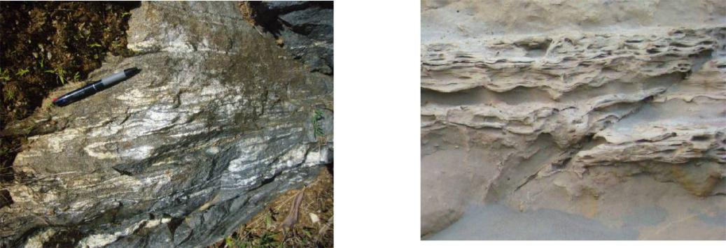

(C) mineral stretching lineation (D) joint

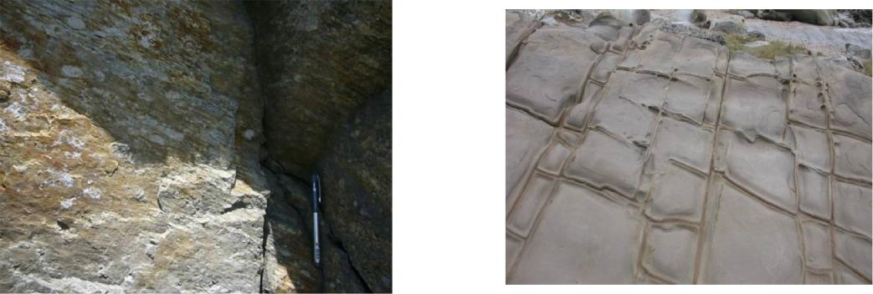

(E) . flame (loading) structure

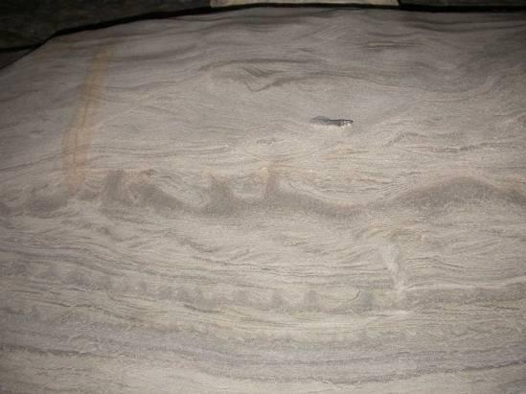

31. What is likely to occur (Highly probable – H or Least probable – L) in a low oxygen atmosphere environment older than 2 billion years ?

A. __________ Photosynthetic prokaryotes

B. formation of banded-iron formations

32.. The following map shows the surface horizontal velocity obtained from GPS measurements. The vector length at each point is proportional to the magnitude of the velocity, and the arrow indicates the direction of movement. Please answer the following questions.

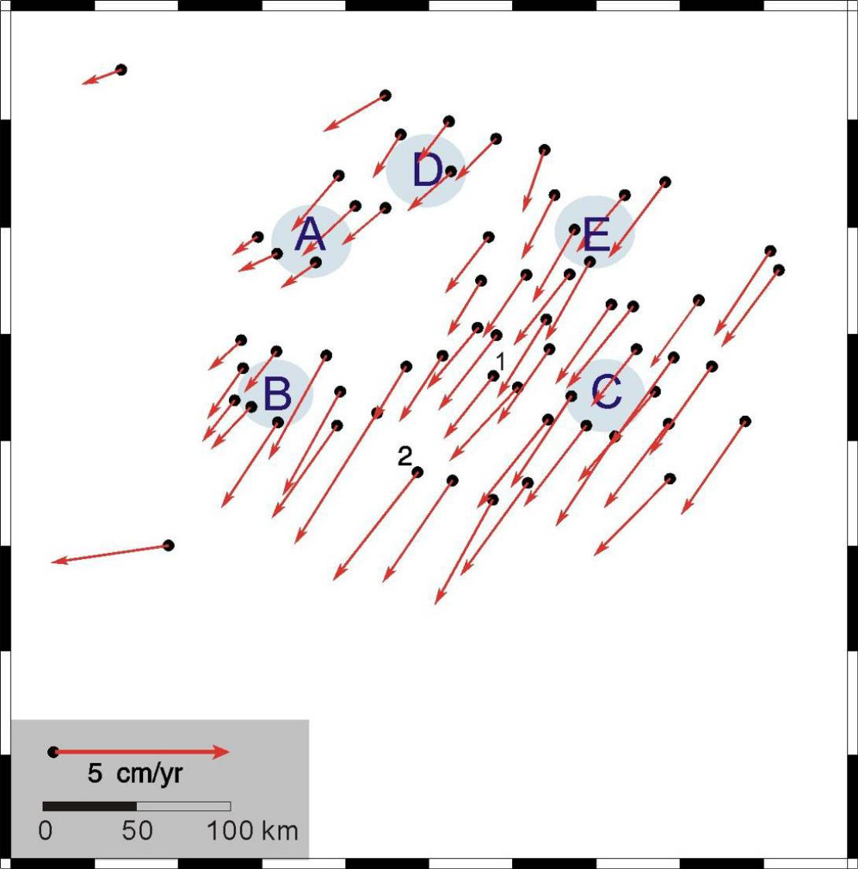

A). Based on the spatial variations of velocities, which stress environment setting is correct?
  - A: compressive, B: extensional, C: shearing

  - A: shearing, B: compressive, C: extensional

  - A: extensional, B: shearing, C: compressive

  - A: compressive, B: shearing, C: extensional

B). According to the surface velocity, please roughly estimate the strain rate between points 1 and 2. Please show your calculations and give your answer in scientific notation in 2 significant figures. (Hint: the unit for strain rate is per year)

C). Assume higher strain rate indicates higher earthquake activities. Which area C, D, or E in map has the highest earthquake activity?

C, D, E

33.. We know the pattern of radiated seismic waves depends on the fault geometry. The polarity (direction) of the first P-wave arrival varies between seismic stations at different direction from an earthquake. Figure (a) illustrates this concept for a strike-slip earthquake on a vertical fault. The first motion is either “push”, for stations located such that material near the fault moves toward the station, or “pull”, where the motion is “away from” the station. The downward first motion indicates that the P-wave is radiated from a region where the focal source is being relatively compressed, as shown in the lower-right quadrant in Figure (a).


Epicenter

Compressional Extensional
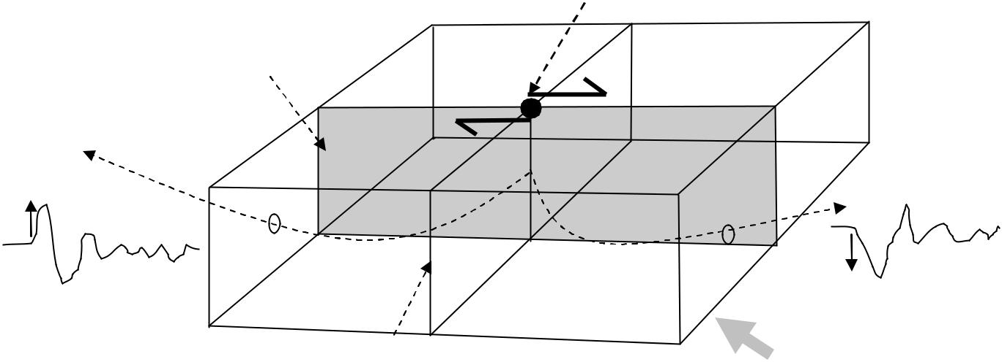

Fault plane

“Push”

Extensional Compressional

Auxiliary

plane

Figure (a)

“Pull”

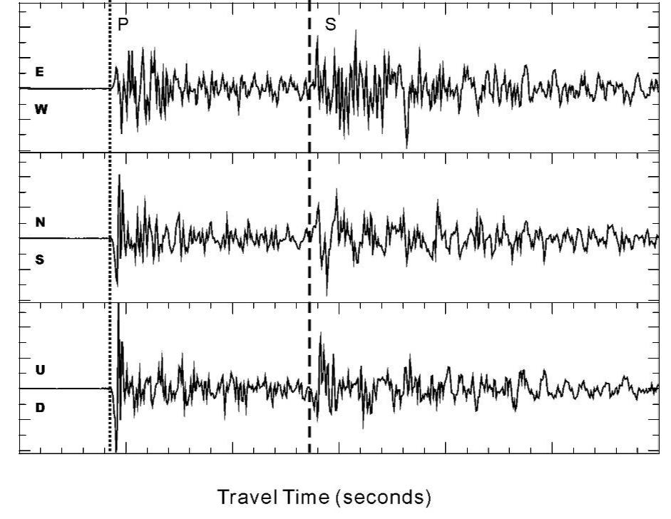

Amplitude (10-4 cm)

2
1
0
1
-2
2
1
0
1
-2
2
1
0
1
-2 | 15 | 20 | 25 | 30 | 35 | 40
10

Figure (b)

Figure (b) shows 3-component seismograms recorded at a station 85 km away from the epicenter. They are east-west, north-south and up-down, respectively. Please answer the following questions according to Figures (a) and (b).

- Which description listed below is correct?

  - First direct P wave is radiated through the extensional quadrant and the first direct S wave is radiated through the compressive quadrant.

  - First P wave is radiated through the compressive quadrant and the first S wave is radiated through the extensional quadrant.
  - Both first P and S waves are radiated through the extensional quadrant.

  - Both first P and S waves are radiated through the compressive quadrant.

- Please infer the location of the recording station with respect to the epicenter in terms of the first motions. (2 pt)

(A) North north west | (B) South south west
(C) North north east | (D) South south east

34.. Connect the fault types with the correct figures. (2 pts)

Normal fault
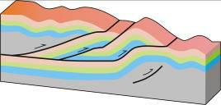


Thrust fault


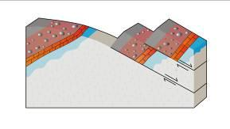

Dextral transverse fault




Sinistral transverse fault

35.. The figure below shows the variations of deuterium isotope (δD), the atmospheric concentrations of the CO₂, CH₄, and N₂O derived from air trapped within ice cores from

Antarctica. The shading indicates the interglacial warm periods. The lowest panel shows the globally distributed δ¹⁸O records of benthic foraminifera, a proxy for global ice volume fluctuations.
Downward trends in the benthic δ¹⁸O curve reflect increasing ice volumes on land. Stars of different colors are the N₂O, CH₄, and CO₂ concentrations in the atmosphere in the year 2007. (1 ka = 1000 years ago; 0 ka = 1950 AD) (Source: IPCC AR4, 2007).
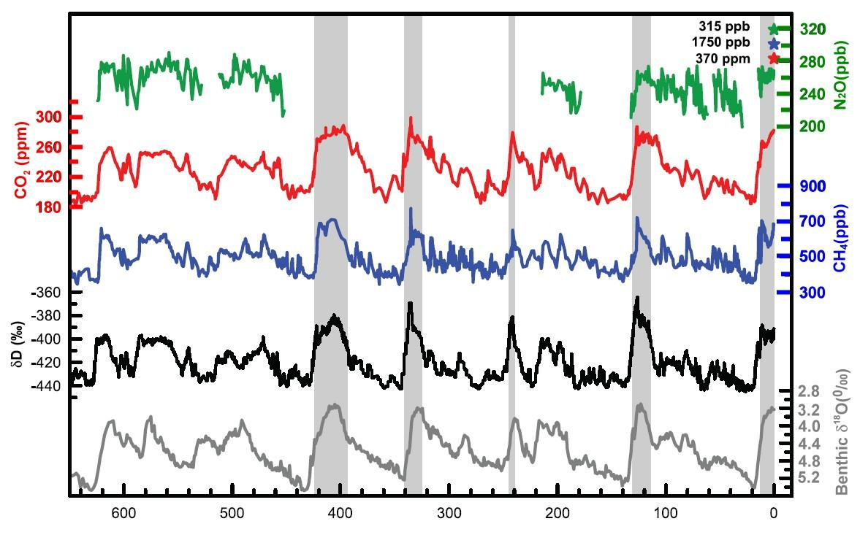

Time (ka)

- Over the last 650 ka, when did the CH₄ content exceed the current level?

(A) 400 ka (B) 125 ka (C) 330 ka (D) 315 ka (E) none of these

- The magnitude of δ¹⁸O is directly proportional to the ice volume on land (note the scale on graph is inverted). When was the most recent time that the ice volume on land was maximum?

- 420 ka
(B) 220 ka
(C) 125 ka
(D) 20 ka
(E) 0 ka

