PRACTICAL WORK
(40 points total)
Introduction
In the Figure 1 you can see the location of the study area. It is located on the banks of Sava River, approximately 24 km upstream from the confluence of Sava River to Danube in the Belgrade, Serbia.

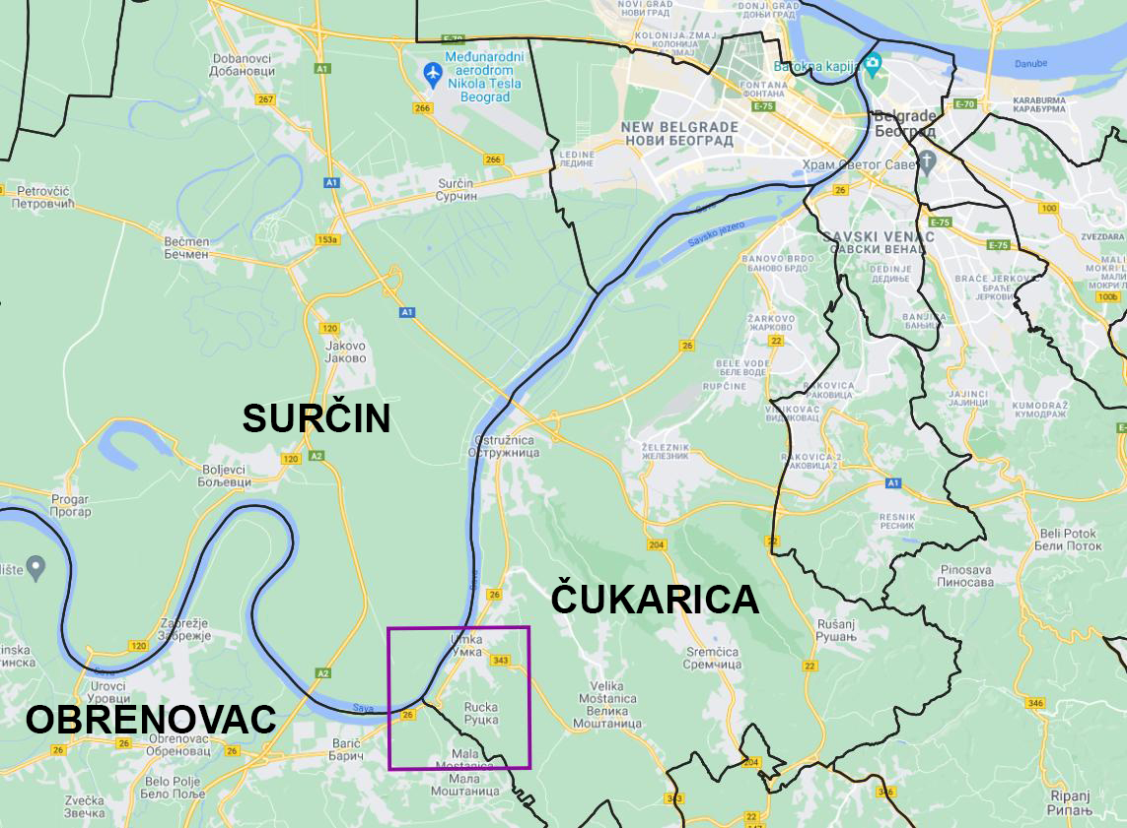
Figure 1: Study area location

Study area belongs to three municipalities of the Belgrade City territory. On the right bank of Sava River municipalities of Čukarica and Obrenovac are located and on the left river bank there is Municipality of Surčin. For this practical work focus will be on the right bank of Sava River where two big landslides are located, Landslide “Umka” and Landslide “Duboko” (Figure 2). Although predisposition for landslide process existed – terrain is made of Neogene clay sediments, there are significant slopes and the Sava River could intensify this process, there were no significant landslide activity, until 1960s and 1970s when the Municipality of Čukarica decided to give building permits for family and weekend houses. Lack of proper water drainage and sewer system, which made soil soaked with water, deforestation, intensive road traffic and pressure from building construction, started process that will create one of the largest landslides in Serbia, named “Umka” after settlement on which territory is located. Since the landslide is about 30 meters deep, and it has volume of about 7 million m³, there are no adequate measures that could stop this process entirely. As a result of landslide movement many houses were demolished and damaged and infrastructure took heavy damage. This area is now degraded with significant limitations in land use. On the territory of the Municipality of Obrenovac there is also a landslide named “Duboko”, but not as large as Landslide “Umka”, and with drastically lower landslide process intensity.
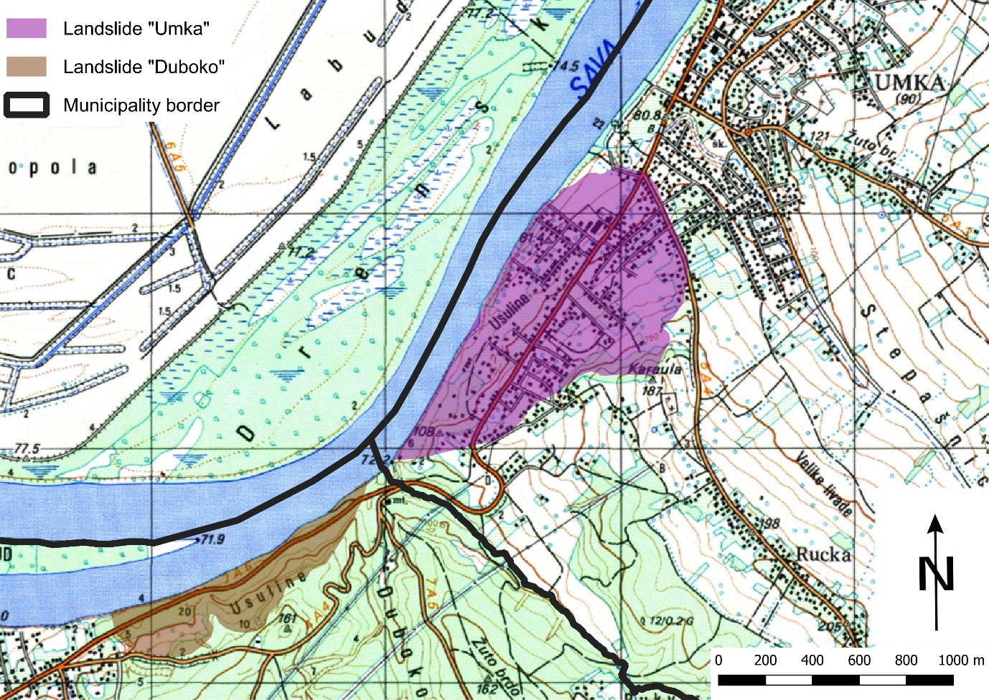
Figure 2: Topographic map from year 1989 with mapped landslides

Task 1 (5 points)
What is the size of the Landslide “Umka” area in hectares, taking into account that size of grid cells shown in Figure 3 are 200x200 meters?
Answer: _______ hectares
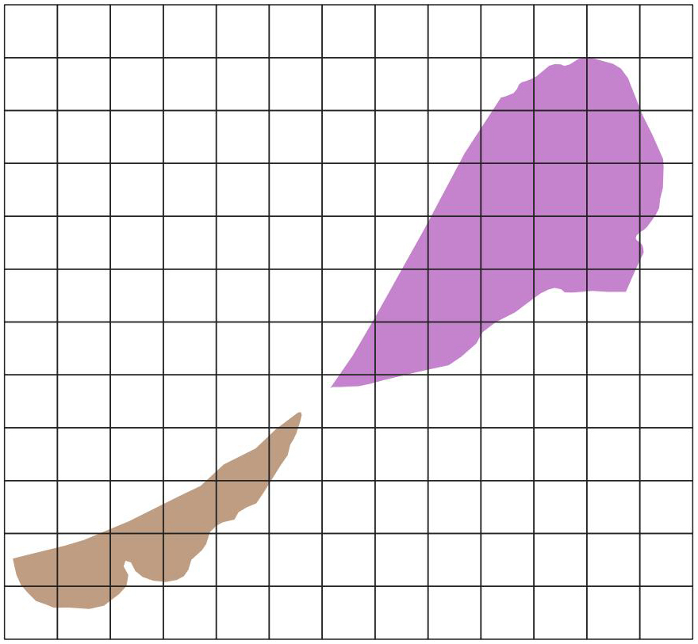
Figure 3: Landslides “Umka” and “Duboko” with 200x200 m cell size grid

Task 2 (5 points)
Due to landslide process there are constant distortions in road infrastructure. The Republic of Serbia is paying large amounts of money each year so that traffic is possible on state road “26” that is going through Landslides “Umka” and “Duboko”. What is the length of the state road “26” between points “A” and “B” in meters?
Answer: _______ meters
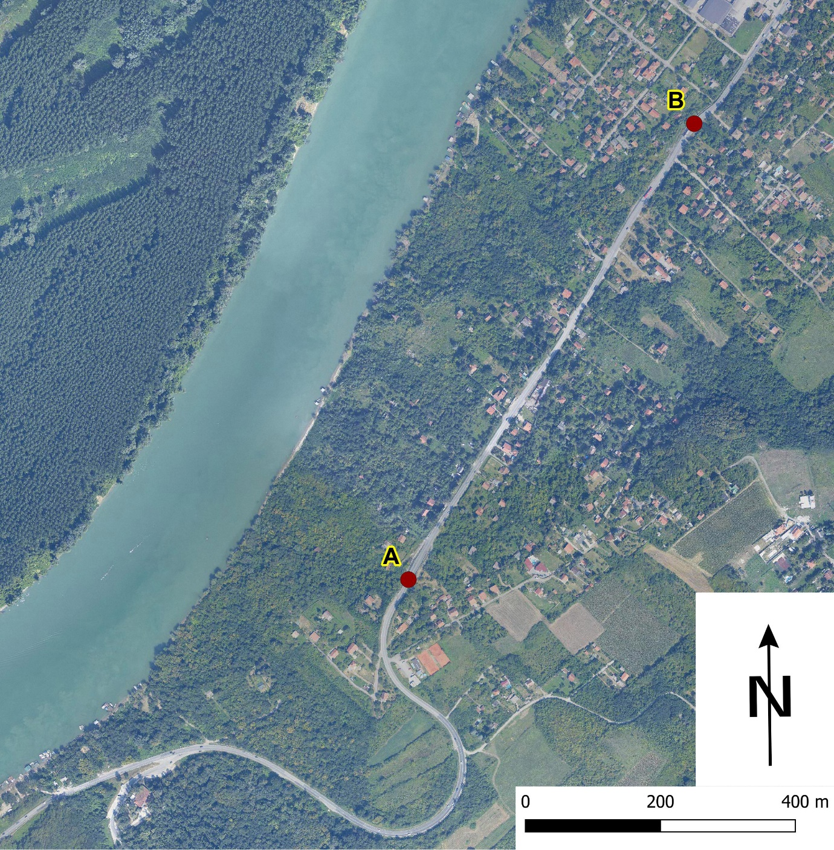
Figure 4: Part of Landslide “Umka” with state road “26”

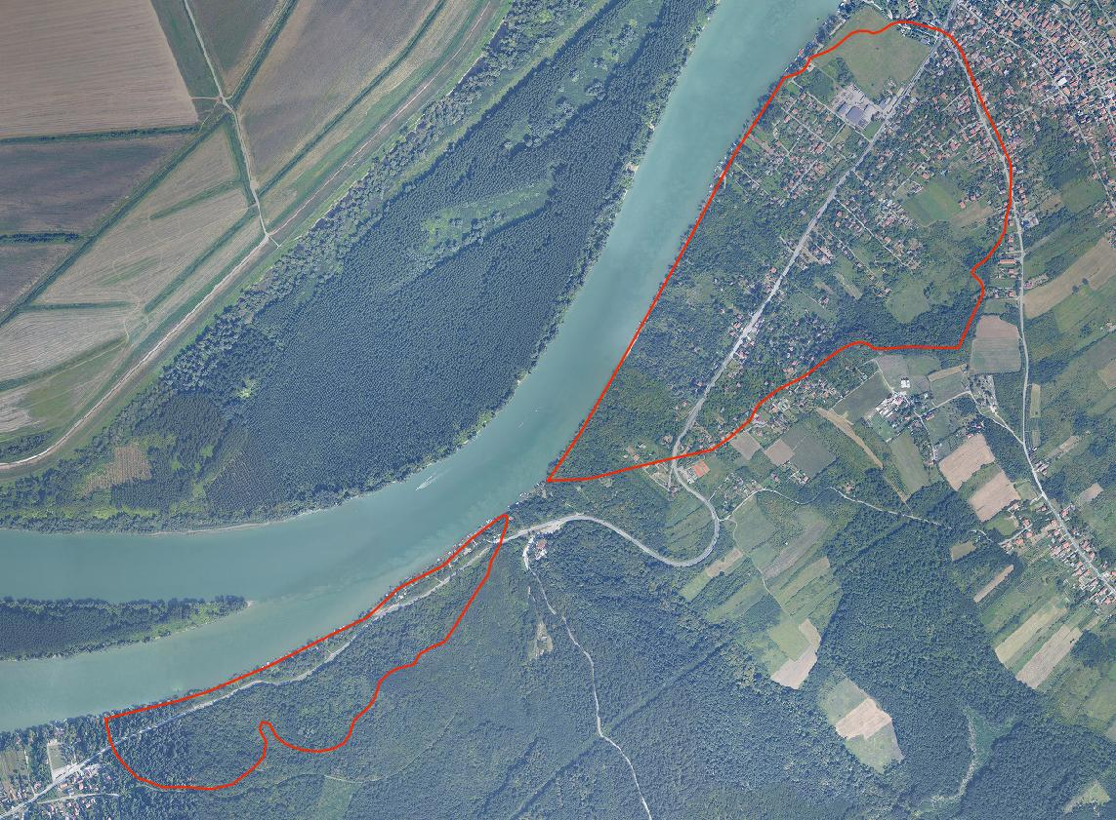
Figure 5: Orthophoto image of landslides “Umka” and “Duboko”

Task 3 (5 points)
Although terrain of the landslides “Umka” and “Duboko” is almost the same when it comes to geology and slopes, landslide process intensity of “Duboko” is not even close to the intensity of process on “Umka”. Specify why is that so.
Answer: _______________________________________________________________________________________________________________________________________________________________________________________________________________________________________________________________________________________________________________________________________________________________________________________

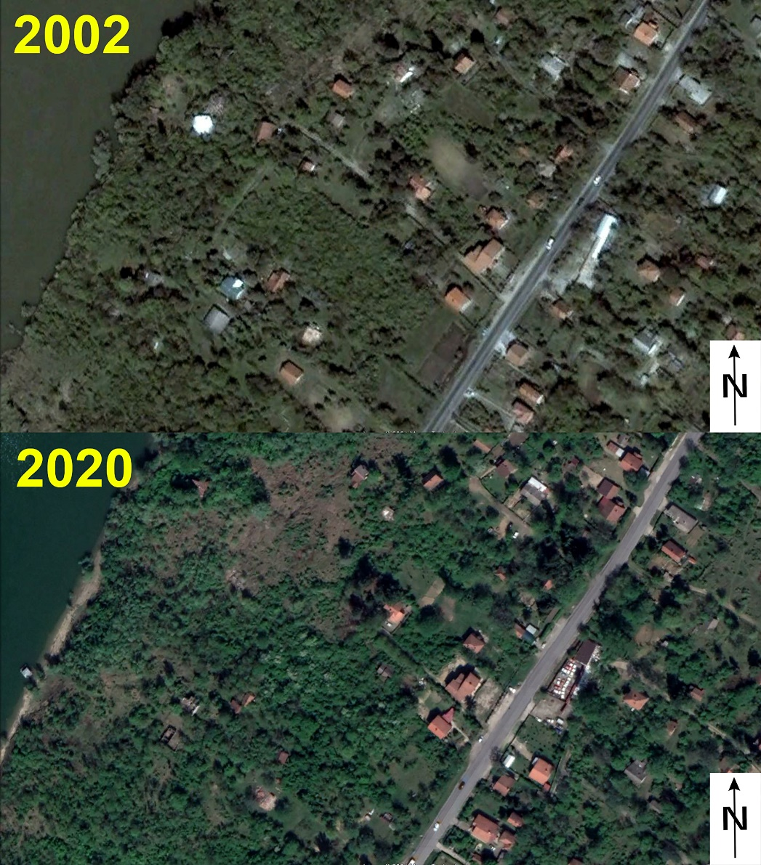
Figure 6: Satellite images from years 2002 and 2020

Task 4 (5 points)
Specify and analyze major land cover/land use changes from year 2002 to year 2020, shown in Figure 6, Northwest from state road “26”.
Answer: _______________________________________________________________________________________________________________________________________________________________________________________________________________________________________________________________________________________________________________________________________________________________________________________
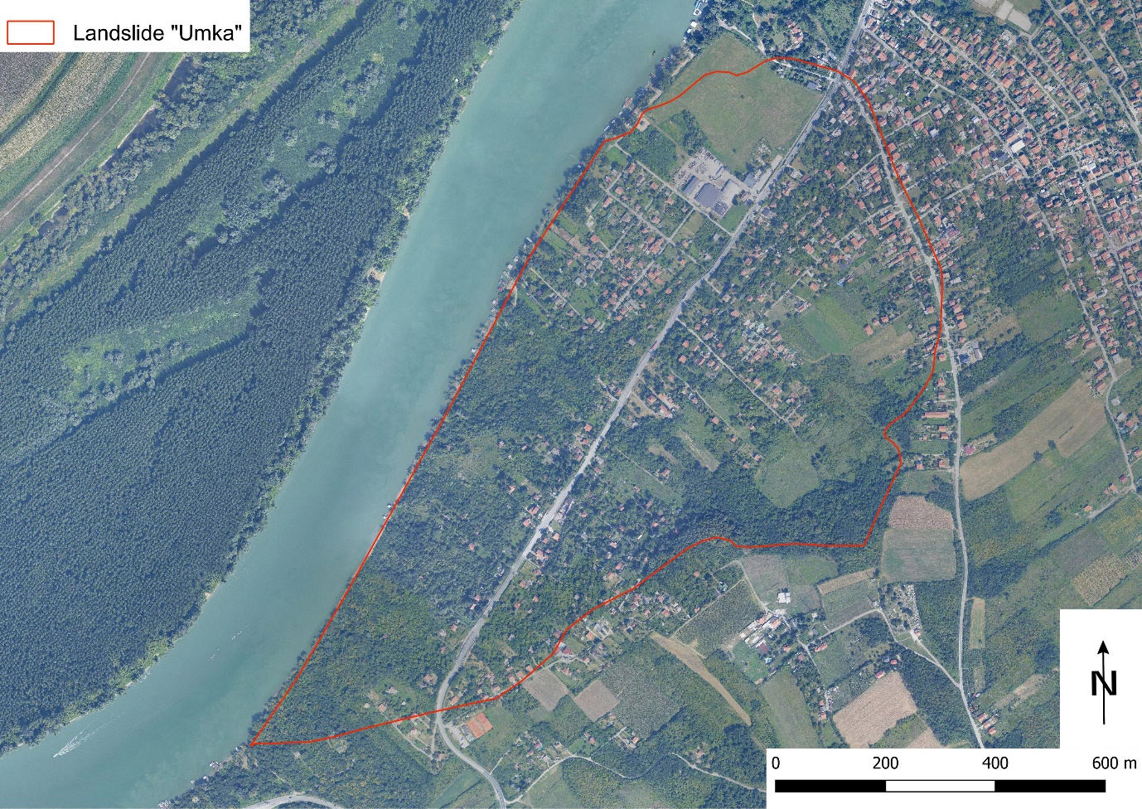
Figure 7: Orthophoto image of Landslide “Umka”

Task 5 (5 points)
Specify two most suitable land use types/activities for the part of Landslide “Umka” area between state road “26” and the Sava River.
Answer: _________________________________________________________________________________________________________________________________________________________________________________________________________________________________

Task 6 (15 points)
Taking into accout recent state and land use/land cover types of the Landslide “Umka” perform the SWOT analysis with maximum two answers for each category.
Strengths  1. ________________________________________  2. ________________________________________ | Weaknesses  1. ________________________________________  2. ________________________________________
Opportunities  1. ________________________________________  2. ________________________________________ | Threats  1. ________________________________________  2. ________________________________________

